Merchant Operation Manual
(for Cross-border Payment)
v1.9

Change log
Date | Author | Version | Content
2015-01-16 | Huo.Liang | v1.0 | First version
2015-02-11 | Huo.Liang | v1.1 | Change communication security module
2015-02-28 | Huo.Liang | v1.2 | Add refund interface
2015-03-30 | Meng.Xu | v1.3 | Add CNY currency
2015-05-08 | Meng.Xu | v1.4 | Add reconciliation response information
2015-06-01 | Meng.Xu | v1.5 | Update description information
2015-07-21 | Yan.Min | v1.6 | Change query order request parameter
2015-11-03 | Yan.Min | v1.7 | Add currency
2015-12-01 | Tang.Li | v1.8 | Support multiply customs  Add Chongqing custom extension fields
2015-12-23 | Wu.Shaotong | V1.9 | Add buyForexKind field for "Merchant submit order"  Add "Personal foreign exchange code" list

Contents
Change log 2
1 Background 4
1.1 Summary 4
1.2 User 4
1.3 Basic concepts 4
2 Message protocol 5
2.1 Protocol format 5
2.2 Communications Security 6
3 Business process diagram 7
3.1 Payment process 7
3.2 Reconciliation process 7
4 Business interface specification 8
4.1 Preparation 8
4.2 Data type 8
4.2.1 Type description 8
4.2.2 Length description 8
4.3 Common parameter 8
4.3.1 Common parameter in all response 9
4.4 Payment 9
4.4.1 Merchant submit order 9
4.5 Query 12
4.5.1 Query order 12
4.5.2 12
4.6 Reconciliation 13
4.6.1 Reconciliation file download 13
4.7 Notification 15
4.8 Refund 16
4.8.1 Merchant Refund 16
5 Appendix 18
5.1 Response Code Description 18
5.2 Payment state 22
5.3 International balance code 23
5.4 Currency 23

Background

Summary
Merchant operation manual describe the public interface between payment platform and merchant's system. The major content of this manual include payment process, communication contract, communication interface description. It integrates with merchant's online system to provide secure online payment method between customers, merchants and banks.

User
This specification applies to cross-border payment merchant.

Basic concepts
Merchants: refers to the enterprise who provide goods or services directly or indirectly in their platform, make agreement party payment with Lakala, is one of payee in this specification.
User: refers to the enterprise or individual agents who purchase goods or services in merchant's website, is the payer in this specification.

Message protocol

Protocol format
Send and receive data by HTTPS protocol.

- Request Link:
https://IP/ProductLink
- Character Encoding：
Send and receive data by UTF-8 encoding.
- Request Method：
Use http post method to submit request. Http get method is not provided.
- Request Parameter Example：
"merId":"0001", //merchant ID
"ver":"1.0.0", //interface version number
"ts":"20141103155648000001", //timestamp,yyyyMMddHHmmssnnnnnn
"reqType":"B0101", //request business type
"encKey":"c7dujfehqfje9hc84vd1esjfupdzzzq03fyl99gr9hg57qch2iwz", //Encrypted symmetric key
"encData":"r6c04x5rp1fzz6hbg7rzuqvtyxytl5mjmryhqpvszxdwhnmtvgr47l60tgysfj9jzzlc2jw8zcywq76xg943g03tnzv1aqdjm2mabihj2eagsm3vxwf2u8qvk7v48ype" //Encrypted json
"mac":"6dty7demwz1obmo8z169es8rqx8j0hpm1mhe744g" //MAC
- Response：
There are two types of response, foreground and background notification.
When merchant send request, payment platform will send foreground and background notification.After payment finish and user's internet browser turn to merchant's website, payment platform will send foreground notification to user. Background notification used in notifying merchant after payment finish.

Response Parameter Example：
"merId":"0001", //merchant ID
"ver":"1.0.0", //version number
"ts":"20141103155648000001",//timestamp yyyyMMddHHmmssnnnnnn
"reqType":" B0101", //request business type
"encData":"r6c04x5rp1fzz6hbg7rzuqvtyxytl5mjmryhqpvszxdwhnmtvgr47l60tgysfj9jzzlc2jw8zcywq76xg943g03tnzv1aqdjm2mabihj2eagsm3vxwf2u8qvk7v48ype" //Encrypted json
"mac":"6dty7demwz1obmo8z169es8rqx8j0hpm1mhe744g" //MAC

Communications Security
Safety principle: use asymmetric keys combined symmetric key, asymmetric keys used for authentication/attestation (signature), and exchange symmetric key(one time one key); Symmetric key used to encrypt the business data; Use timestamp to prevent replay.

Business process diagram

Payment process
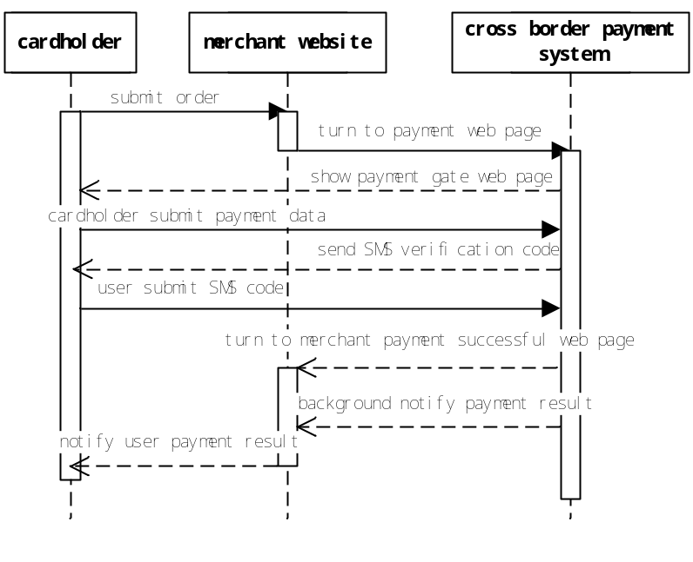

Reconciliation process
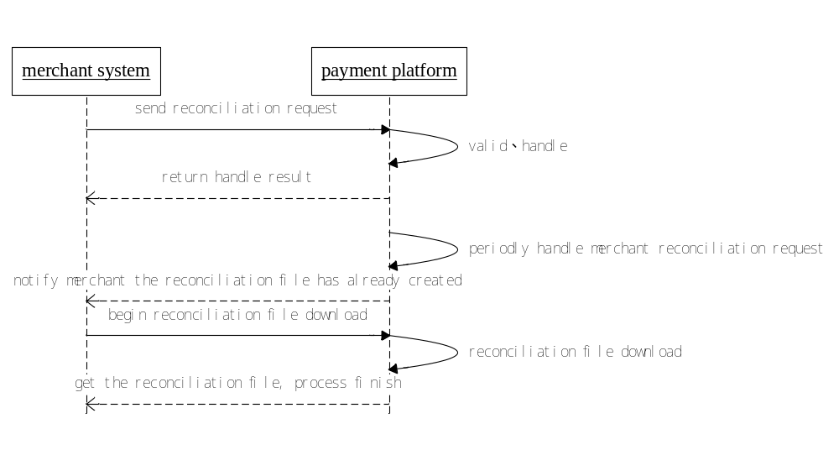

Business interface specification

Preparation
When merchant want to use Lakala payment interface, merchant need to register with the payment platform firstly. After that, the merchant will get the following information:
- The merchant ID in the payment platform
- Access key(merchant private key, payment platform public key)

Data type

Type description
The data types used in exchange messages between platform and merchant can be described as follows:
- A Letter.
- AN Letter or Number.
- ANS Letter,Number,Special Character.
- AS Letter,Special Character.
- U Chinese Character.
- O Out-of-order Object

Length description
- A10 Letter, fixed length, max length 10 characters
- A..10 Letter, Variable-length, max length 10 characters
- AN..32 Letter or number, Variable-length, max length 32 characters
- U..99 Chinese character, Variable-length, max length 99 Chinese characters
Time zone example : GMT+8 means eastern district 8

Common parameter
Note: the * symbol parameters are required.
All parameter names using camel nomenclature.

Common parameter in all response
Parameter Specification
Field Name | Type | Full Name | Description
retCode* | N4 | response code | Return this parameter in the case of success or fail.
retMsg* | U..99 | response description | Return this parameter in the case of success or fail.

Payment

Merchant submit order
Requester : Merchant.
Responder: Lakala payment platform.
【Functional Description】：
After merchant's system receives a cardholder's request for payment, merchant's system will submit a pay request to payment platform.
Request business type“reqType”=“B0002”. Response business type“reqType”=“B1021”.

Request (Merchant->Platform)
Business Parameter
Field Name | Attribute | Full Name | Description
merOrderId* | ANS..64 | merchant order ID | merchant order ID  character  Must use letter,number,-,_, And begin with a letter or number.  The order ID submitted by merchant's system, it must be unique in merchant's system.
currency* | A3 | order currency (mark currency) | Lakala provide all currency list
orderAmount* | NS..13 | order amount | DECIMAL(10,2)  Unit yuan.  Such as: order amount is 10$, orderAmount parameter value should be passed 10.00.
payeeAmount | NS..13 | payee amount | DECIMAL(10,2)  Unit is yuan.  Such as: payee amount is 10$, payeeAmount parameter value should be passed 10.00.
orderSummary | ANSU..256 | order summary | English or Chinese character
orderTime | N14 | order time | Characters, totally 14  Format is: year[4character]month[2character]day[2character]hour[2character]minute[2character]second[2character]  Such as：20071117020101
orderEffTime | N14 | order valid time | Number characters, totally 14  Format is: year[4character]month[2character]day[2character]hour[2character]minute[2character]second[2character]  Such as：20071117020101
timeZone | ANS..6 | timezone | Timezone of merchant's server, such as: GMT+8 represent east district 8
pageUrl* | ANS..256 | After payment finish, user's internet browser will turn to merchant website link. | Absolute address. If bgUrl is blank, pageUrl could not be blank. If pageUrl is blank, bgUrl could not be blank.
bgUrl* | ANS..256 | Background response address | Absolute address. If bgUrl is blank, pageUrl could not be blank. If pageUrl is blank, bgUrl could not be blank.
bizCode* | N6 | Cross-border business type | Refer Appendix
ext1 | AN..512 | Extension field1 | English or Chinese character string.  After payment finish, response to merchant as its original case.
ext2 | AN..512 | Extension field2 | English or Chinese character string.  After payment finish, response to merchant as its original case.
extension | O | Extension Info
cuId | ANS..10 | Custom | - Guangzhou custom  - Shanghai custom  - Ningbo custom  - Beijing custom  - Hangzhou custom  - Chongqing custom
bizTypeCode | ANS..3 | Business Type Code  (Chongqing custom Required) | I10 Direct-purchasing import  I20 Online shopping bonded import  E10 General export B2C  E20 General export B2B  E30 Bonded export B2C  E40 Bonded export B2B  E50 Virtual commodity export
goodsFee | N18 | Goods Fee  (Chongqing custom Required) | DECIMAL(16,2)
taxFee | N18 | Tax Fee  (Chongqing custom Required) | DECIMAL(16,2)
buyForexKind | N4 | Buy forex kind | re.“Personal foreign exchange code”

Response(Platform->Merchant)

Business Parameter
Field Name | Attribute | Full Name | Description
merOrderId* | ANS..64 | merchant order ID | Merchant order ID, unique in merchant's system
transactionId* | AN..64 | sequence ID | Lakala sequence ID
currency* | A3 | order currency | Lakala provide currency list
payAmount* | NS..13 | order amount | DECIMAL(10,2)  Return the order amount except use coupon.  Unit is yuan.  Such as: order amount is 10$, parameter value should be passed 10.00.
payRMBAmount* | NS..13 | order actual payment amount | DECIMAL(10,2)  Return the actual user's payment amount except use coupon.  Unit is yuan.  Such as: order amount is 10$, parameter value should be passed 10.00.
orderFee | NS..13 | order fee | DECIMAL(10,2)  Order fee amount
exchangeRate | NS..15 | exchange rate | DECIMAL(10,4)  foreign exchange purchasing rate
dealTime* | N14 | payment successful time | The time when the payment platform deal with the transaction.  Number characters, totally 14  Format is: year[4character]month[2character]day[2character]hour[2character]minute[2character]second[2character]  Such as：20071117020101
payResult* | N1 | payment state | Payment state, 0: payment not begin, 1: payment success, 2: payment fail
ext1 | AN..512 | Extension field1 | English or Chinese character string.  After payment finish, response to merchant as its original case.
ext2 | AN..512 | Extension field2 | English or Chinese character string.  After payment finish, response to merchant as its original case.

Query

Query order
Requester: merchant.
Responder: Lakala payment platform.
【Functional Description】：
Merchant's system send http request to payment platform, the payment platform will return the order status according to merchant's order ID.
Request business type “reqType”=“B0007”

Request (Merchant->Platform)
Business Parameter
Field Name | Attribute | Full Name | Description
merOrderId* | ANS..64 | merchant order ID | Merchant order ID, unique in merchant's system
transactionId | AN..64 | sequence ID | Lakala sequence ID
ext1 | AN..512 | Extension field1 | English or Chinese character string.  After payment finish, response to merchant as its original case.
ext2 | AN..512 | Extension field2 | English or Chinese character string.  After payment finish, response to merchant as its original case.

Response(Platform->Merchant)
Business Parameter
Field Name | Attribute | Full Name | Description
orderTime | N14 | Order time | Time of order submit  Number characters, totally 14  Format is: year[4character]month[2character]day[2character]hour[2character]minute[2character]second[2character]  Such as：20071117020101
merOrderId* | ANS..64 | merchant order ID | Merchant order ID, unique in merchant's system
transactionId* | AN..64 | sequence ID | Lakala sequence ID
payResult* | N..2 | order state | Order stat：  payment：  0：payment not begin,1：payment finish,2：invalid;3：reversal;4：cancel;99：close  refund:  0： merchant confirm（pending）,1：refund success,2：refund fail;9：request refund;10：invalid refund（refuse refund）
cnyAmount | NS..13 | RMB amount | DECIMAL(10,2)  Return the actual user's payment amount except use coupon.  Unit is yuan.
exchangeRate | NS..15 | exchange rate | DECIMAL(10,4)  foreign exchange purchasing rate
ext1 | AN..512 | Extension field1 | English or Chinese character string.  After payment finish, response to merchant as its original case.
ext2 | AN..512 | Extension field2 | English or Chinese character string.  After payment finish, response to merchant as its original case.

Reconciliation

Reconciliation file download
Requester: merchant.
Responder: Lakala payment platform.
【Functional Description】：
Merchants regularly send reconciliation HTTP request to the payment platform, payment platform return the state of the request. Payment platform push the file download link to merchant after generating reconciliation file. Merchant's system will download the reconciliation file according to the link. Reconciliation file only contains successful trade or refund.
Request business type “reqType”=“B0008”

Request (Merchant->Platform)
业务参数
Field Name | Attribute | Full Name | Description
startDate* | N8 | start date | Number, totally 8 character  Format: year[4character]month[2character]day[2character]  Such as: 20071117
endDate* | N8 | end date | Number, totally 8 character  Format: year[4character]month[2character]day[2character]  Such as: 20071117
notifyAddr* | ANS..256 | notify address | The reconciliation file address that platform push to merchant.

Synchronous Response(Platform->Merchant)
业务参数
Field Name | Attribute | Full Name | Description
startDate* | N8 | start date | Number, totally 8 character  Format: year[4character]month[2character]day[2character]  Such as: 20071117
endDate* | N8 | end date | Number, totally 8 character  Format: year[4character]month[2character]day[2character]  Such as: 20071117

Asynchronous Response(Platform->Merchant)
业务参数
Field Name | Attribute | Full Name | Description
downLoadUrl* | ANS..512 | reconciliation file download address

Refer to common response parameter.
Reconciliation file name format description: merchantID_begingDate_endDate.txt
Such as: 105290054110500_20131201_20131203.txt

Reconciliation file format
First line: beginDateEndDate|total count|total amount|total fee
Secondline:merchantID|merchantOrderID|LakalaSequenceID|
transDate(yyyyMMddHHmmss)|transState|transAmount(cent)|fee|orderCNYAmount
|markPriceCurrency|trans Type(0 pay 1 refund)

Thirdline:merchantID|merchantOrderID|LakalaSequenceID|
transDate(yyyyMMddHHmmss)|transState|transAmount|fee|orderCNYAmount|
markPriceCurrency|trans Type(0 pay 1 refund)
After merchant receive reconciliation file notify, need response “OK”.

Notification

Payment result notify
Requester：Lakala payment platform.
Responser：merchant.
【Functional Description】：
After payment finish, payment platform will send merchant(bgUrl) a notification about the payment result.
Request business type “reqType”=“B0005”

Request (Platform->Merchant)
业务参数
Field Name | Attribute | Full Name | Description
merOrderId* | ANS..64 | merchant order ID | merchant order ID, unique in merchant's system
orderTime | N14 | merchant order time | merchant order submit date  Number, totally 14character  Format: year[4character]month[2character]day[2character]hour[2character]minute[2character]second[2character]  Such as: 20071117020101
currency* | A3 | order currency | Lakala provided currency list
orderAmount | NS..13 | merchant order amount | DECIMAL(10,2)  Return the actual user's payment amount except use coupon.  Unit is yuan.  Such as: order amount is 10$, orderAmount parameter value should be passed 10.00.
payAmount* | NS..13 | order actual payment amount | DECIMAL(10,2)  Return the actual user's payment amount except use coupon.  Unit is yuan.  Such as: order amount is 10$, orderAmount parameter value should be passed 10.00.
dealTime | N14 | payment success time | Number  When the payment platform deal with the transaction
orderFee | NS..13 | fee | DECIMAL(10,2)  The fee occur in the transaction
exchangeRate | NS..15 | exchange rate | DECIMAL(10,4)  foreign exchange purchasing
transactionId* | AN..64 | sequence ID | Lakala sequence ID
payResult* | N1 | payment stat | Payment state: 0: payment not begin, 1: payment success, 2: payment fail
ext1 | AN..512 | ext1 | String  Same with the payment submit request's ext1 field
ext2 | AN..512 | ext2 | String  Same with the payment submit request's ext2 field

Response(Merchant->Platform)
Business Parameter
Field Name | Attribute | Full Name | Description
merOrderId* | ANS..64 | merchant order ID | merchant order ID, unique in the merchant's system
transactionId* | AN..64 | sequence ID | Lakala sequence ID
ext1 | AN..512 | ext1 | String  Same with the payment submit request's ext1 field
ext2 | AN..512 | Ext2 | String  Same with the payment submit request's ext2 field

Refund

Merchant Refund
Requester: merchant.
Responser: Lakala payment platform.
【Functional Description】：
Merchant send refund request to payment platform by using this specification.
Request business type “reqType”=“B0006”

Request (Merchant->Platform)
Business Parameter
Field Name | Attribute | Full Name | Description
orderTime | N14 | merchant order time | merchant order submit date  Number, totally 14character  Format: year[4character]month[2character]day[2character]hour[2character]minute[2character]second[2character]  Such as: 20071117020101
merOrderId* | ANS..64 | merchant order ID | original payment request's “merchant order ID”
seqId* | ANS..64 | refund order ID | merchant refund order ID, unique sequence ID(max 32character)
orderAmount* | NS..13 | order amount | DECIMAL(10,2)  Such as 10$, submit a 10.00
retTime* | N14 | refund date | Number, totally 14character  Format: year[4character]month[2character]day[2character]hour[2character]minute[2character]second[2character]  Such as: 20071117020101
retAmt* | NS..13 | refund amount | DECIMAL(10,2)  Such as 10$, submit a 10.00
retCny* | A3 | refund currency | Lakala provide currency list
ext1 | AN..512 | ext1 | String  Same with the payment submit request's ext1 field
ext2 | AN..512 | Ext2 | String  Same with the payment submit request's ext2 field

Response(Platform->Merchant)
Business Parameter
Field Name | Attribute | Full Name | Description
orderTime | N14 | merchant order time | merchant order submit date  Number, totally 14character  Format: year[4character]month[2character]day[2character]hour[2character]minute[2character]second[2character]  Such as: 20071117020101
merOrderId* | ANS..64 | merchant order ID | original payment request's “merchant order ID”
seqId* | ANS..64 | refund order ID | merchant refund order ID, unique sequence ID(max 32character)
transactionId* | AN..64 | order currency | Lakala provide currency list
retStatu* | N1 | refund state | Number: 0 refund success, 1 processing, 2 refund fail
ext1 | AN..512 | ext1 | String  Same with the payment submit request's ext1 field
ext2 | AN..512 | Ext2 | String  Same with the payment submit request's ext2 field

Appendix

Response Code Description
Response code totally are 4 character, the definition of every code can be described as follows:
00000 means success, 9999 means payment platform error.

Code | Description
0000 | Success
0001 | Request fail
0002 | Request parameter is incorrect
0003 | Fail to fetch internal business handle class
0004 | Internal business process return blank
0005 | Fail to send request to bank
0006 | Banking system returns a failure information
0007 | Order does not exist
0008 | This order has already payment succeed, please don't make order again.
0011 | Fail to decode business parameter
0012 | Fail to encrypt response data
0013 | Fail to encrypt 3DES key
0014 | This merchant account has not been valid
0015 | Fail to verify MAC
0016 | Fail to decrypt MAC
0017 | Fail to decrypt merchant symmetric key
0018 | Merchant is invalid or it does not configure quick pay bank
0019 | Order amount is illegal
0020 | The length of URL bytes cannot exceed 256
0021 | Error occur when system transform URL encoding
0022 | URL address is illegal
0023 | Merchant order has already been successful paid
0024 | Order amount cannot be blank, must be bigger than 0.00. And data format is float DECIMAL(10,2)
0025 | order amount less than zero
0026 | Main payee amount must be float type. And data format is float DECIMAL(10,2).
0027 | Main payee amount is less than 0
0028 | Main payee amount should not bigger than order amount
0029 | Main payee amount is blank
0030 | Order time format is incorrect
0031 | Order summary cannot exceed 256 byte
0032 | Error occur when system transform order summary encoding
0033 | Extend field cannot bigger than 512 byte
0034 | Error occur when system transform extend field encoding
0035 | Phone number format is incorrect
0901 | System has not find this card sign information
0038 | Fail to query order information
0046 | This order is invalid
0101 | Cannot query merchant available rate
0053 | Identification length is incorrect
0054 | Card number length is incorrect
0055 | Cannot query the foreign currency that merchant provided
0056 | This merchant don't support this currency
0057 | Platform temporary don't support this currency
0058 | Error occur when system fetch merchant reconciliation request
0070 | Fail to query currency
0301 | Transaction fail, order does not exist or is invalid
0302 | Transaction fail, order information is incorrect
0303 | Transaction fail, system cannot query the merchant sign contract information
0304 | Transaction fail, system temporary does not support visitor transaction.
0305 | Transaction fail, cardholder has not been signed.
0306 | Transaction fail, system temporary do not support this pay method/transaction fail, order does not exist or is out of date/transaction fail, SMS verification fail/transaction fail, fail to pay this order
0307 | Payment fail
0308 | Transaction has been accepted , please query the transaction result later
0309 | Transaction communication is timeout, please query transaction state
0310 | Bank system busy, transaction fail
0311 | The payment SMS authentication code is expired, please fetch SMS authentication code again.
0401 | Fail to fetch SMS verification code
0402 | This SMS verification code which from bank is empty
0403 | Fetch the SMS verification code more than 5 times, order is invalid, please resend a new order
0601 | Original order is not exist
0602 | Refund fail
0603 | Refund order ID is duplicate, please resend refund request
1201 | Fail to resend apply sign SMS
0201 | This user is prevent from trade
0202 | Fail to put order information into storge
0203 | Fail to modify order record
0204 | This merchant do not has quick pay bank configuration
0205 | This merchant do not has fee rule configuration
0206 | Trade amount should bigger than fee amount
0207 | Order amount exceed single time limit
0208 | Order month totally amount exceed limit
0209 | Fail to fetch SMS verification code
0210 | Quick payment user information is incorrect
0211 | This merchant do not has cross border business type
0212 | This merchant do not support this cross border business type
0801 | Fail to apply reconciliation!
0903 | Fail to query sign information
0904 | System busy, please query sign information later
0905 | This card do not has related sign information
0902 | Current status is signed
1203 | System busy, please resend the sign request later
9999 | System internal error

Payment state
0000 means success, others mean fail.

International balance code
ID | Name
223029 | Hotel accommodation
223022 | Tuition and education
122030 | Trade in goods
222024 | Airline ticket

Currency
ID | Currency Code | Name
1 | USD | United States Dollar
2 | CAD | Canadian Dollar
3 | GBP | Pound
4 | EUR | Euro
5 | CHF | Swiss Franc
6 | HKD | Hong Kong dollar
7 | JPY | Yen
8 | AUD | Australian Dollar
9 | CNY | RMB
10 | MYR | Malaysian Ringgit
11 | NZD | New Zealand Dollar
12 | RUB | Ruble
13 | THB | Thai Baht
14 | KRW | South Korean Won
15 | TWD | New Taiwan Dollar

Personal foreign exchange code
Code | Name
0100 | Goods Trade
0210 | Transport
0221 | Study abroad at one's own expense
0222 | Private tourism
0223 | Go abroad for official business
0225 | Other tourism
0230 | Financial and insurance services
0240 | Royalties and licensing fees
0250 | Consulting service
0260 | Other services

